



**Batch: B1 Roll No.:16010421119 Experiment No.:6**

# Aim: Exploring Google Analytics.

**--------------------------------------------------------------------------------------------**

**Resources needed:** Internet and MS-office

# Theory:

**GOOGLE ANALYTICS**

Knowing your audience and what they want is an important success factor for any website. The best way to know your audience is through your traffic stats and this is exactly what Google Analytics does. Google Analytics is one of the top, most powerful tools out there for monitoring and analysing traffic on your website. It shows:

**Who visits your website** – user’s geographical location, which browser did they use, what is their screen resolution, which language they speak, etc.

**What they do when they are on your website** – you can see how long users stay on your website, what pages they are visiting the most, which page is causing the users to leave most often, how many pages an average user is viewing etc.



**When they visit your site** – you can see which time of the day is the hottest for your website. This helps you pick the time to publish your posts. If that time zone is not compatible, then you can schedule your posts.

**Where did they arrive on your website from** – you can see how the user found you. Whether it was through a search engine (Google, Bing, Yahoo etc), social networks (facebook, twitter etc), a link from another website, or a direct type-in. Google Analytics also shows you the breakdown of each traffic source, so you can focus on specific ones if you like.

**How users interact with your site’s content** – You can see how many users clicked on a specific link. In google Analytics, a small code snippet is included in the web pages of website. This code snippet enables Google analytics to track website. During tracking appropriate data is gathered and sent to Google Analytics account.

The Google Analytics Web Tracking method use the Javascript language as it is compatible code of website. These methods have unique names that do not conflict with the existing Javascript methods of website.

# Procedure:

**1.** Document the statistics provided by Google analytics in each report and mention your inferences.

# Results: (Stepwise procedure (with snapshots) for above question)

website we are going to track statistics for - <https://pointer-aid.pettiboy.com/>

this is a website made for kjsce students to calculate the pointer which they might use to predict the pointer and improve study



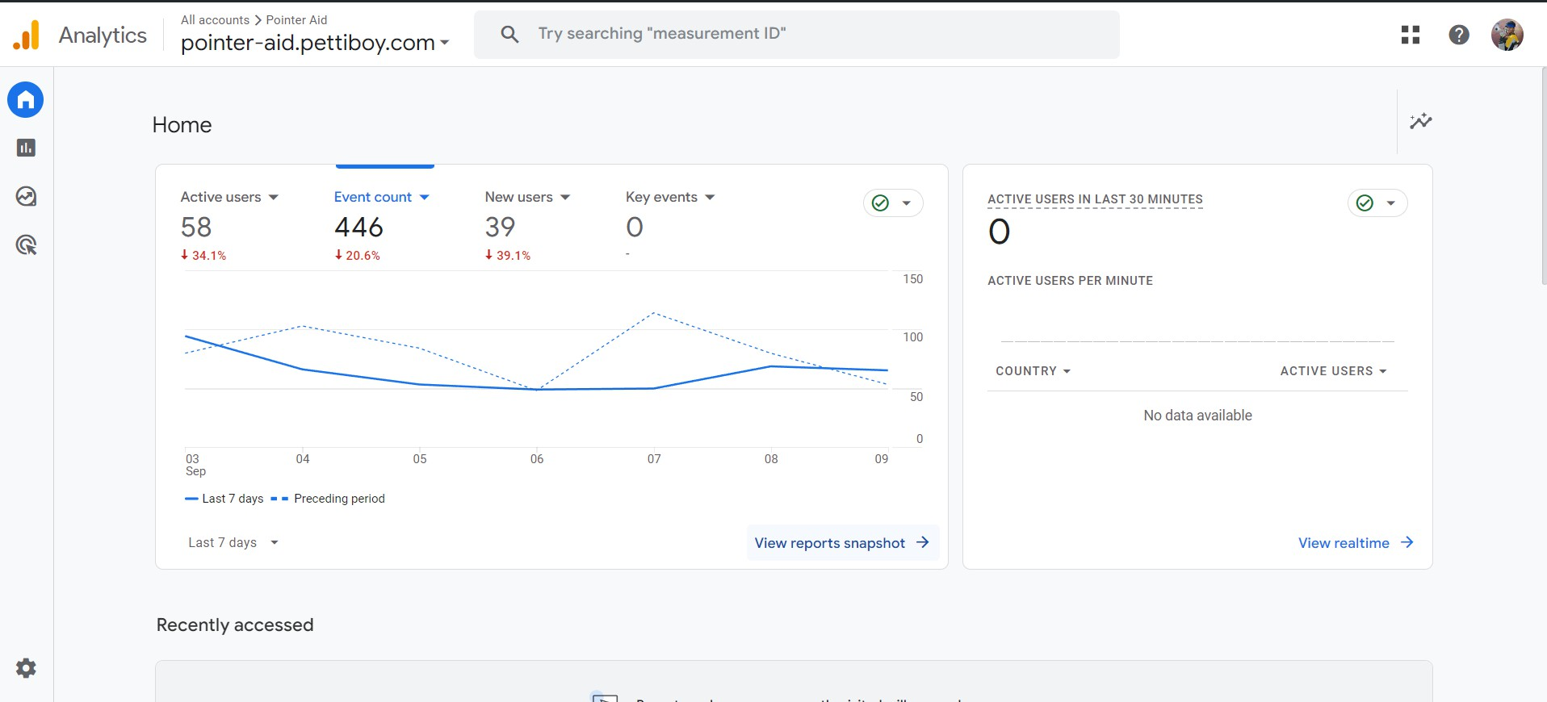

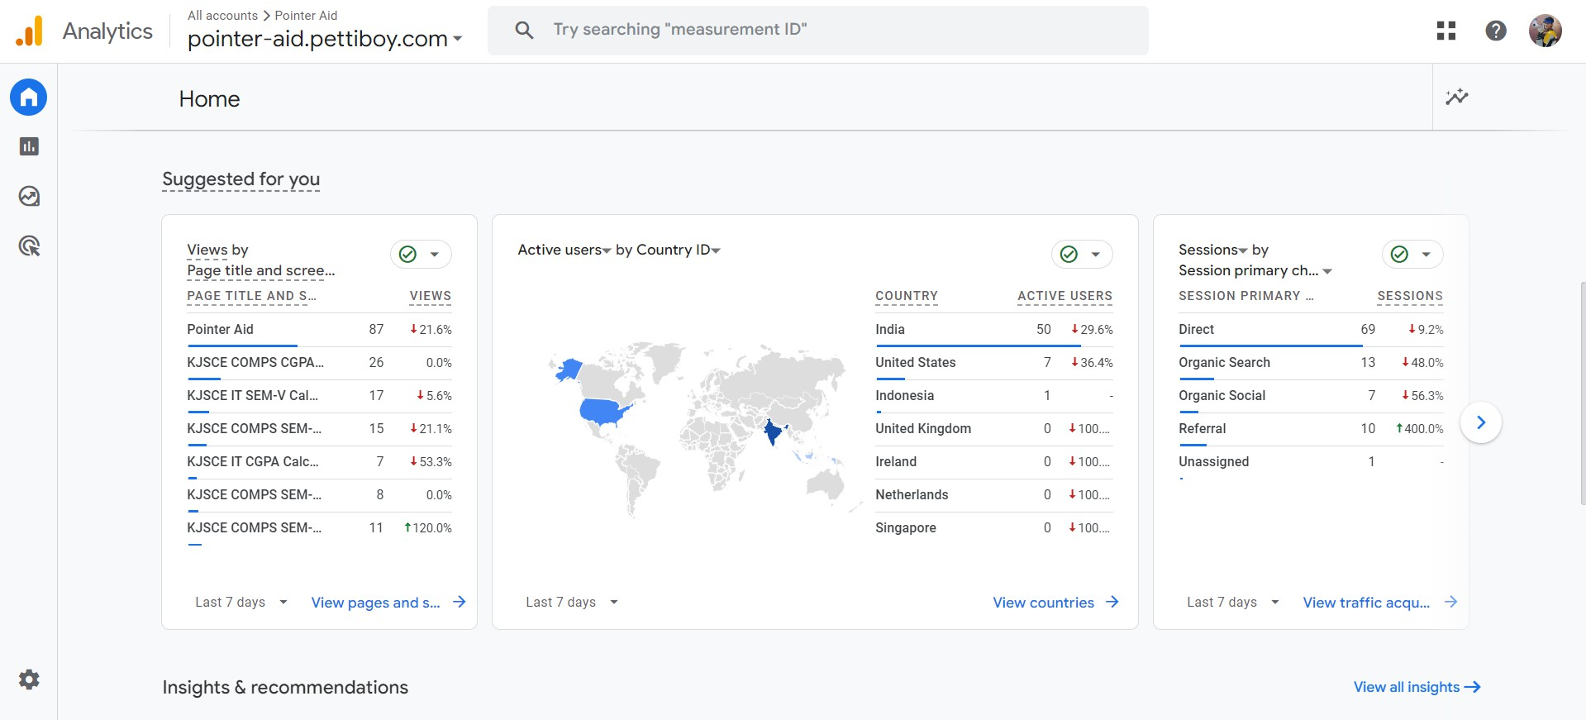



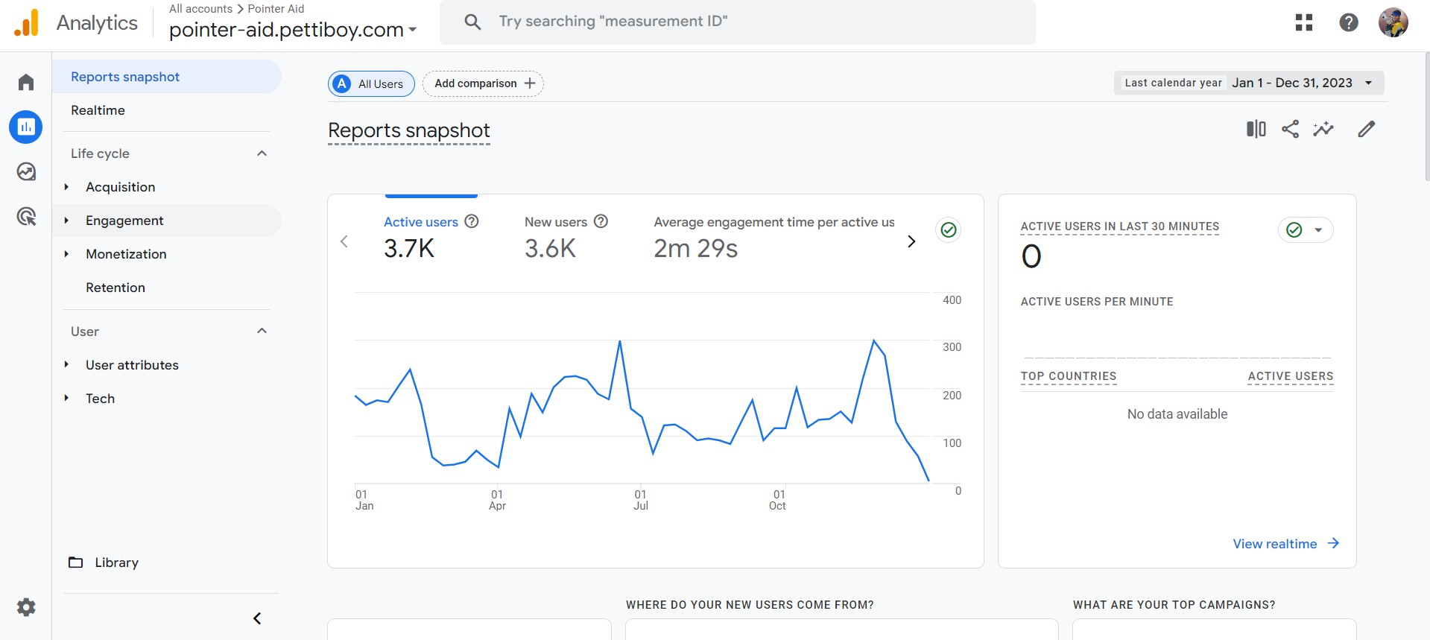

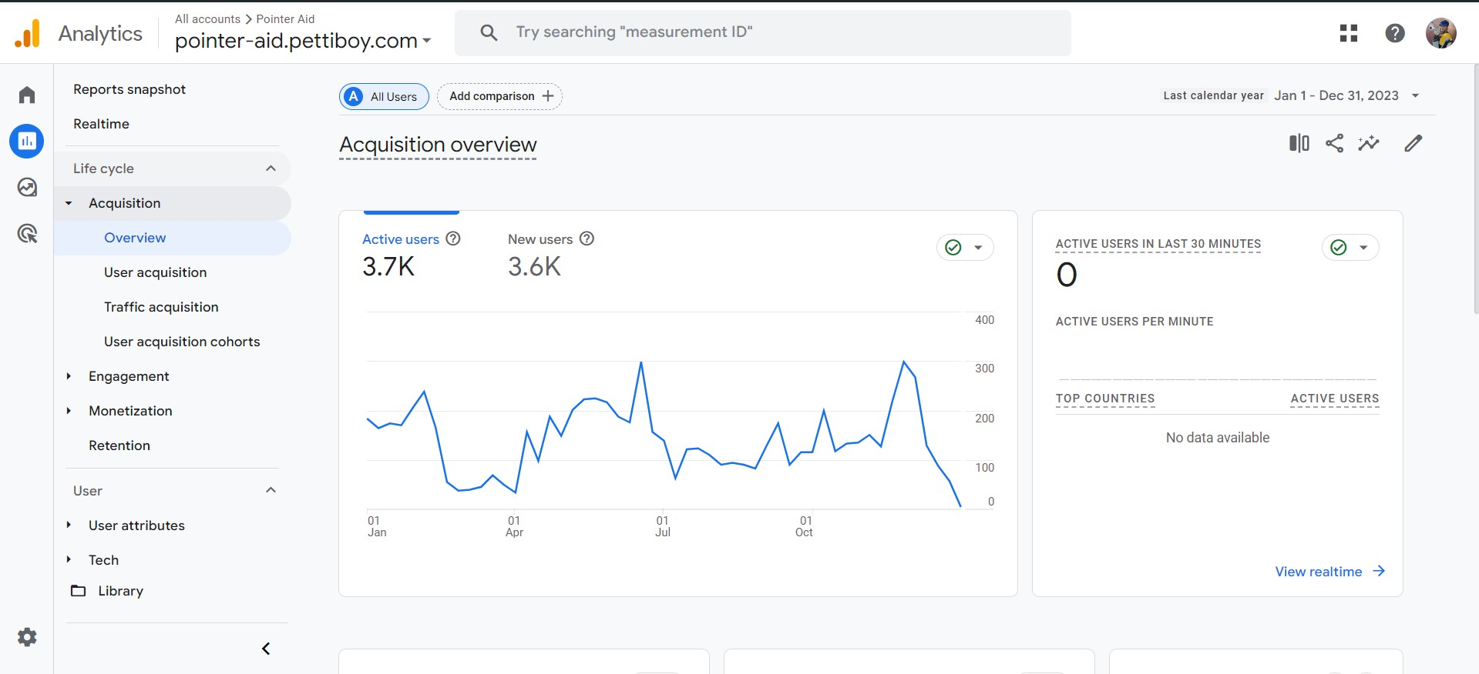



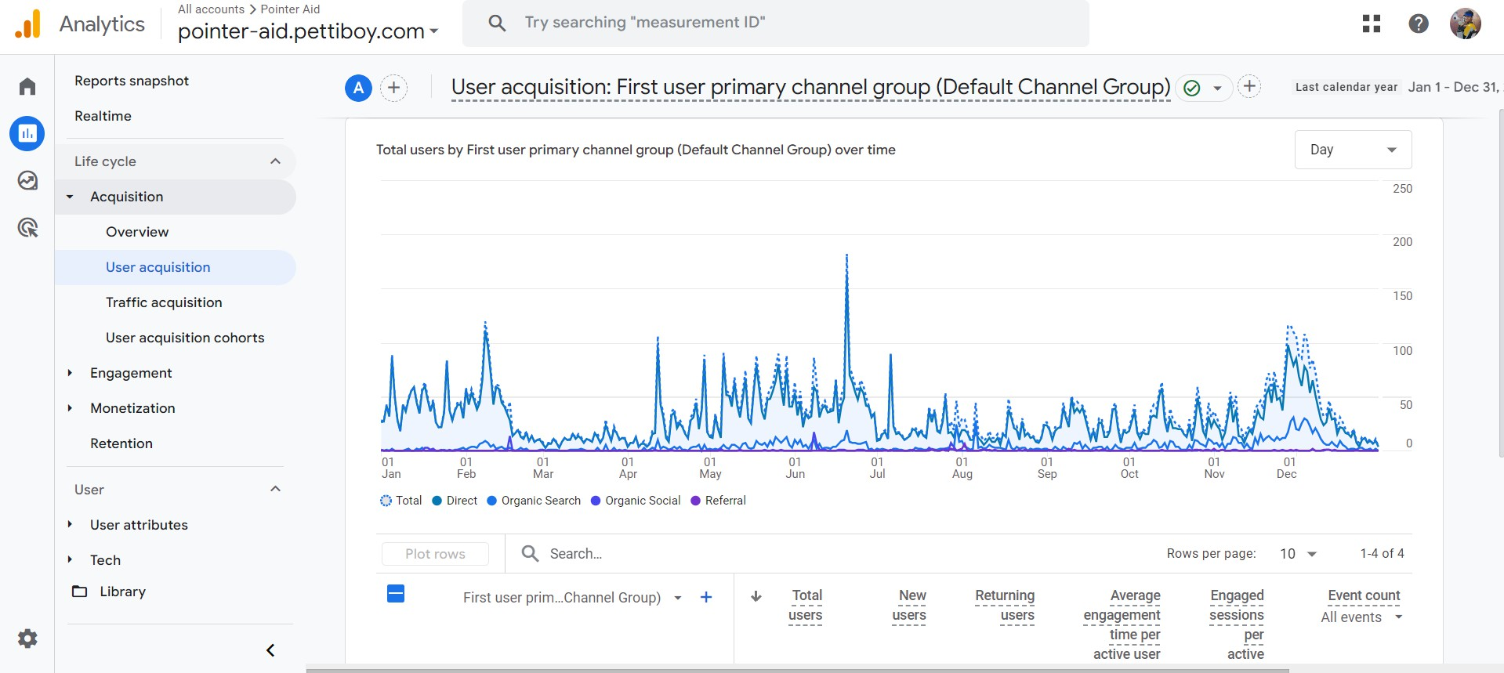

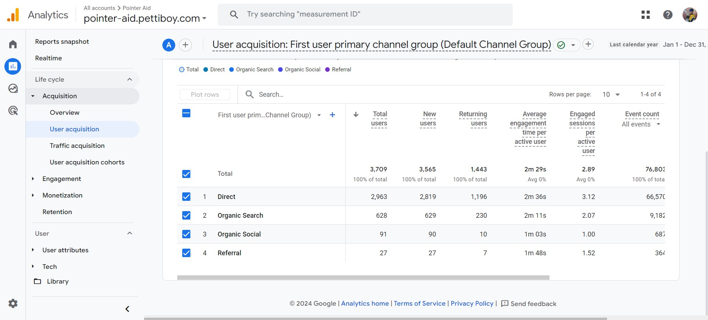



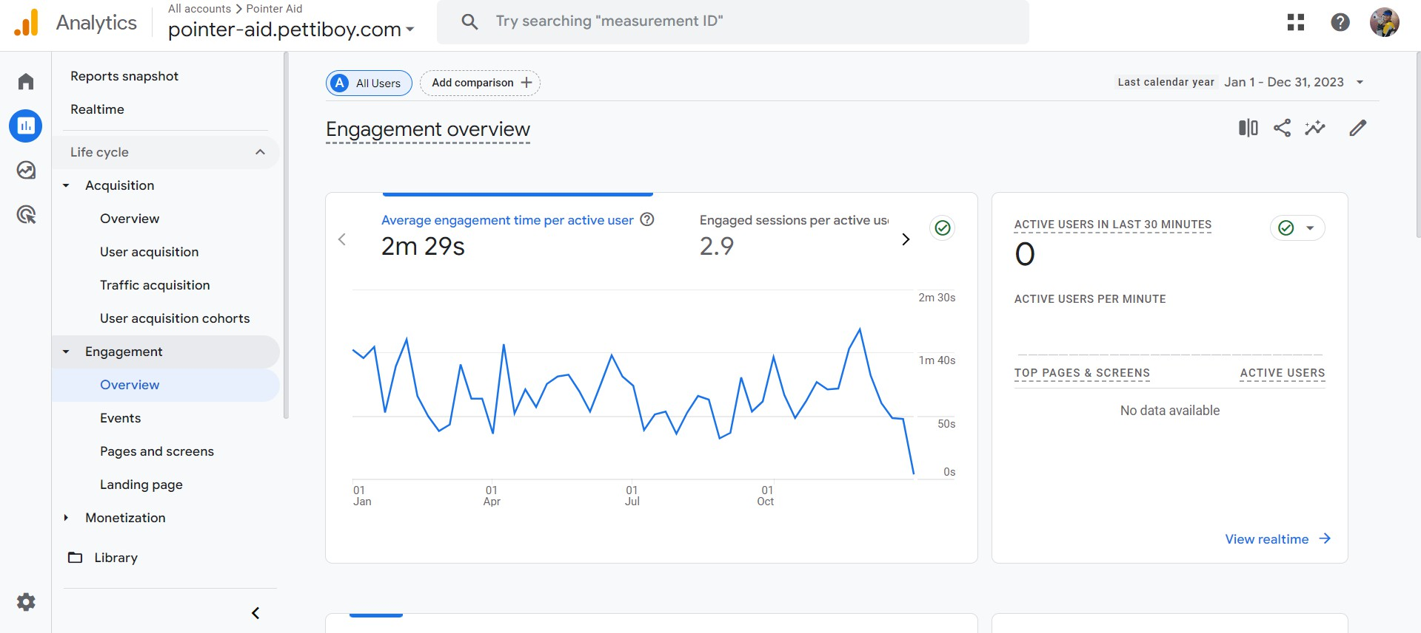

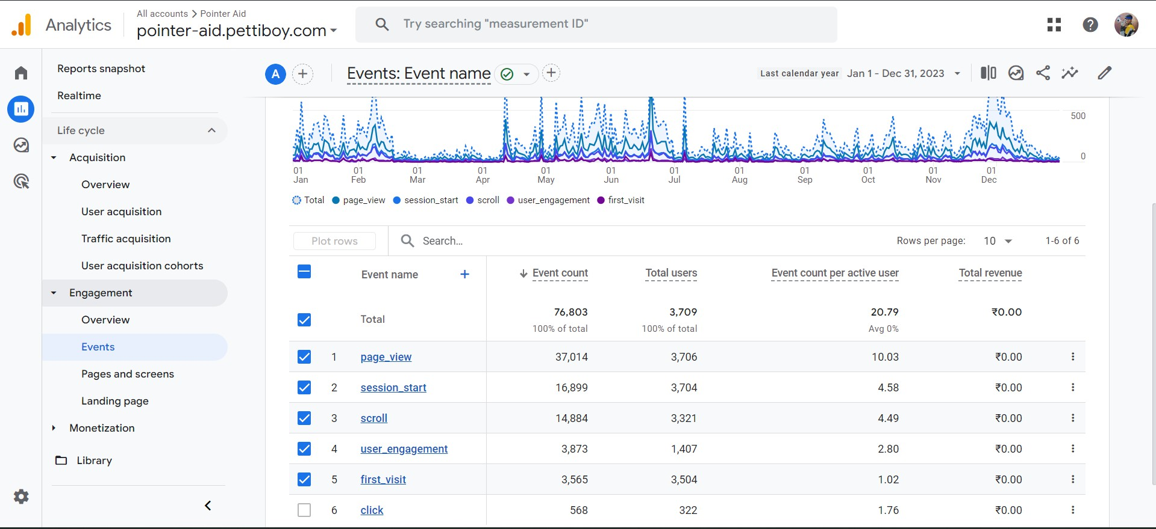

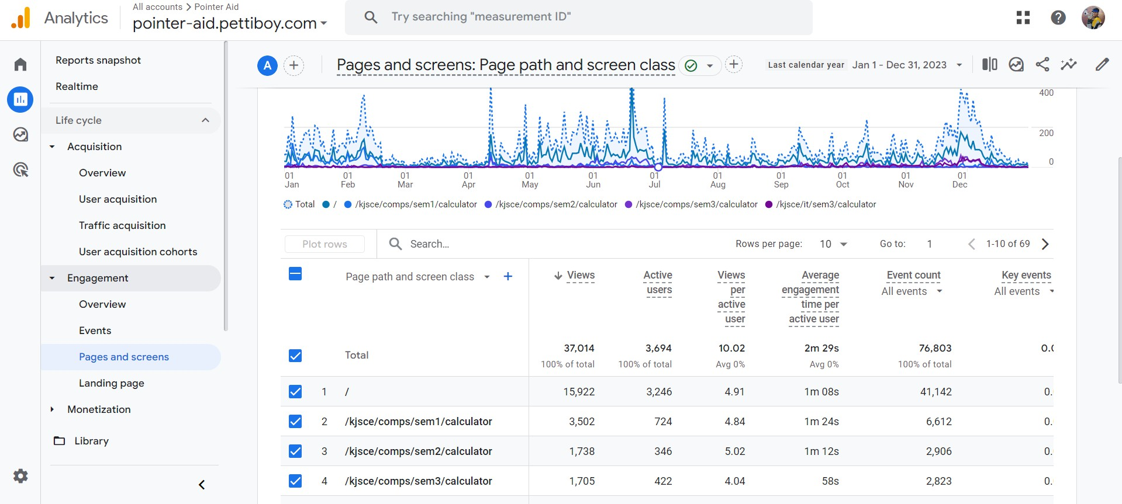

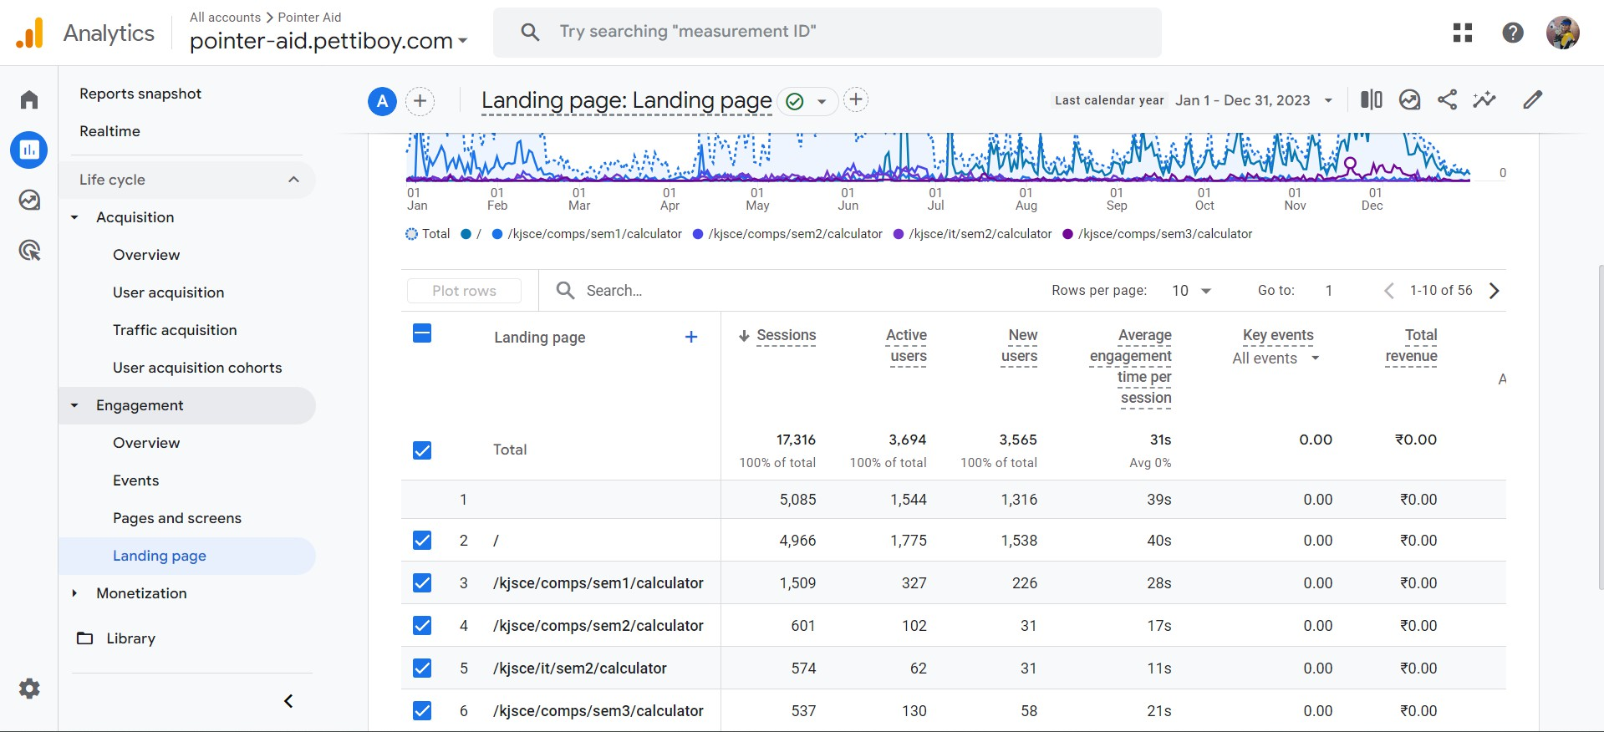

# Questions:



1. Write note on: Diagnosing Conversion rate trouble.

Diagnosing conversion rate issues begins with analyzing the user journey to pinpoint where potential customers drop off. It's essential to assess the quality of traffic from various sources, ensuring it aligns with your target audience. Tools like heatmaps and session recordings can reveal user interaction patterns and identify areas of confusion or friction on your site.

Additionally, reviewing the clarity and effectiveness of your calls-to-action (CTAs), content relevance, and page load speeds can help uncover potential barriers to conversion. A comprehensive, data-driven approach is crucial to identify and resolve the underlying problems.

# Outcomes: CO3 Prepare web site for web marketing and understanding SEO analytics

**Conclusion: (Conclusion to be based on the objectives and outcomes achieved)** used google analytics to analyse the website traffic for me website

# Grade: AA / AB / BB / BC / CC / CD /DD Signature of faculty in-charge with date

**References:**

1. Eric Enge, Stephan Spencer, Jessie Stricchiola, Rand Fishkin, “The Art of SEO, Mastering Search Engine Optimization”, O'Reilly Media; 2nd edition, 2012
2. John I Jerkovic, “SEO Warriors”, O'Reilly Media; 1st edition, 2009



1. RafiqElmansy, “Teach Yourself VISUALLY Search Engine Optimization (SEO)” John Wiley & Sons, 2013